Requirements to complete automated email sending

* Python library package **Selenium**
* **Google Chrome Driver**

**NOTE:** ** In the below examples, CloudKB was being used for testing purposes only. We would look to implement this on 80hg.io service accounts **

Selenium is easily installed using a command like “*pip install selenium*”

However, **Google chrome driver** requires further permissions than I have on my account. It requires super user access as it is installed differently using shell/sudo commands. Following the links will show you guides on how to install it on databricks:

<https://stackoverflow.com/questions/67830079/how-to-use-selenium-in-databricks-and-accessing-and-moving-downloaded-files-to-m>

<https://www.youtube.com/watch?v=_GQcOO9J6Ro>

<https://github.com/coderinboots/install-google-chrome-ubuntu>

To install chromedriver and google driver in databricks root permission are required

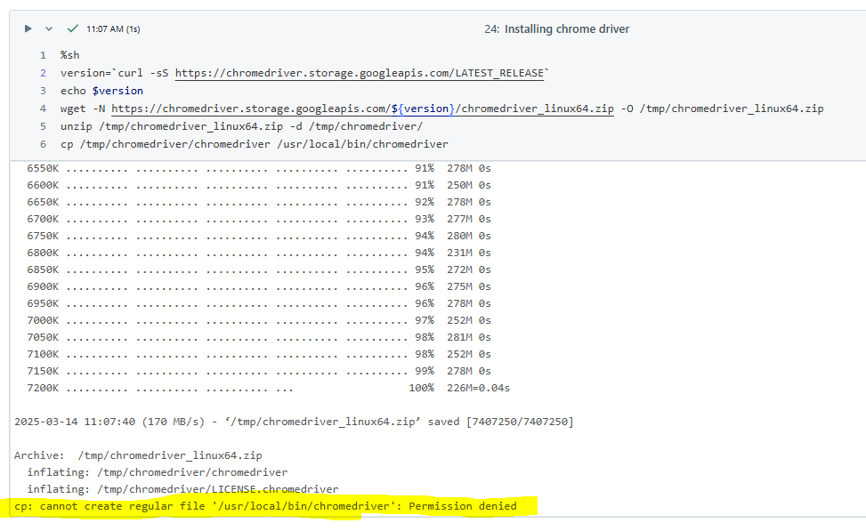

and I keep getting the following message upon execution of commands:

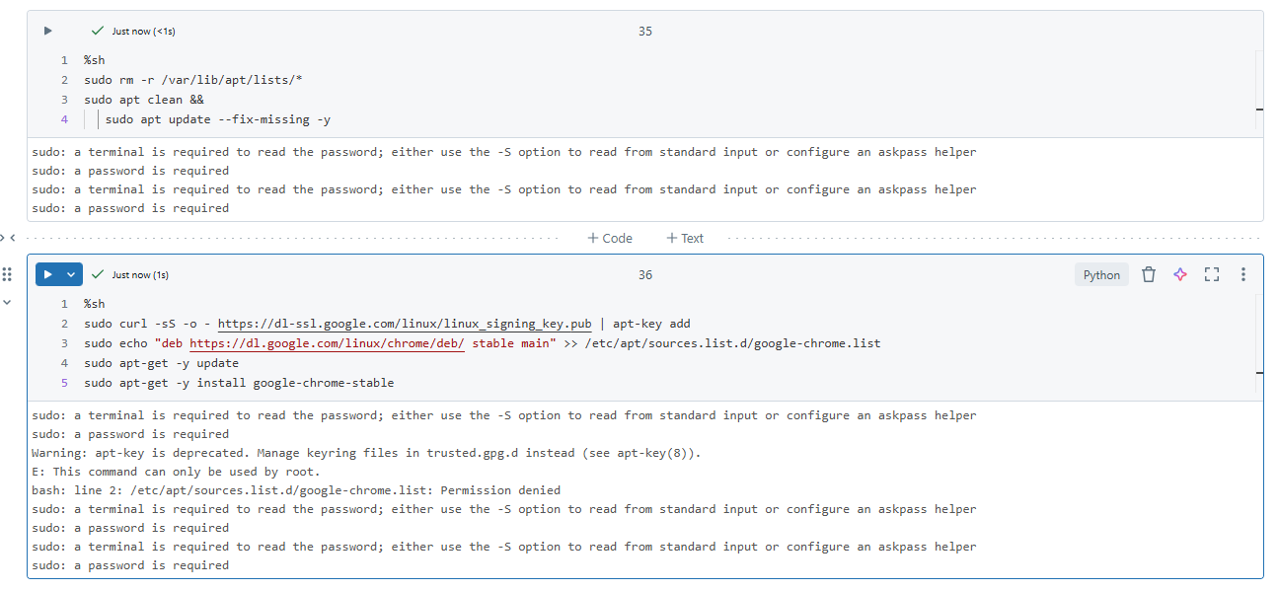

The web browsing automation activities

This section will explain the tasks that selenium will execute:

1. Selenium will go to <https://login.microsoftonline.com/9a3fea61-aaf5-4483-9c58-4416f6c77587/oauth2/v2.0/authorize?client_id=d7af1e9d-3f7c-4c7e-8aeb-ff589878f5ff&response_type=code&redirect_uri=https://localhost&scope=offline_access%20Mail.ReadWrite%20Mail.Send&response_mode=query&state=12345>
2. Select or log in using the account:  
   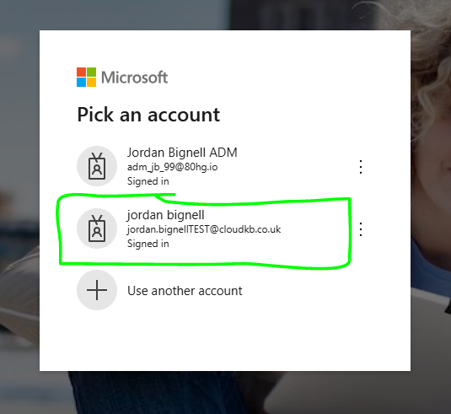
3. Copy the URL and store the code (authorisation code) as a variable within databricks  
   
4. [https://localhost/?code=1.ASEAYeo_mvWqg0ScWEQW9sd1h50er9d8P35Miuv_WJh49f86AEQhAA.AgABBAIAAABVrSpeuWamRam2jAF1XRQEAwDs_wUA9P-PGvCusXbgHYt5DEHJ8GW1KbQrBAn906HDbT8nm0btQU_ENNEpN_CsmZqzwi4BWpYt4ol0fVSGONsNSUyfNIsW6_eoqhokxe2Ywg-6qUdIx7CMOn-fsQH8a9mxAq7Qb6kHMrE3F_8DaUVZM0AY5JUUhE4rTVC-HJOpMQ6F7VZZV0LvDY1moVdGfhypHYXQEc-w7w0ucDcWy8SaElrncUoOFVbKE3biJaNCsIerzOm8UNlrjttt1GB0pYgd7Bk2E8oADzcHuaP-UFxC2jj7rXNN--_sPxkM7oWlbw9lGhPv7oTkMi13CB8t9YiY29LOHPmrxdpKFlrAyxhqlSs2X4sJL3fx5vsl-3R_a81W1IE3ZsPD62a07FBNfmlJFQ7aX_saRatv1kZzGKhFJxmbfQCwfZOAMPdf0_Qvs4gvuyEFT47s5dcI4rlScmtNj3QKFO8WTb7KJ0eO5m3-YYx8vyeVQan-z1iXib0rkcDWcFIXPUNTDsVafWGVX59pe_U__kp-PJynK4o2X076aXAkSV0AqhGO7gwbrBdYhusBCZnm8sZyI49HWes9_l0ONgSHV6B1npE6E2nHxGxCATuAgRxWh46ftMs99RirOfjiNaHKh10QRSKvmUbOKst4hjtKdpz1FbWZmu41h-8UrdooFuX83HKcim4uGew-DmntAA6jLjaMVyQATMsuyvcF3wvG2IXNDztQP8V7nLb4bKrR5w&state=12345&session_state=002ee019-94ec-e4d3-a1d9-0b1f8b7a3564#](https://localhost/?code=1.ASEAYeo_mvWqg0ScWEQW9sd1h50er9d8P35Miuv_WJh49f86AEQhAA.AgABBAIAAABVrSpeuWamRam2jAF1XRQEAwDs_wUA9P-PGvCusXbgHYt5DEHJ8GW1KbQrBAn906HDbT8nm0btQU_ENNEpN_CsmZqzwi4BWpYt4ol0fVSGONsNSUyfNIsW6_eoqhokxe2Ywg-6qUdIx7CMOn-fsQH8a9mxAq7Qb6kHMrE3F_8DaUVZM0AY5JUUhE4rTVC-HJOpMQ6F7VZZV0LvDY1moVdGfhypHYXQEc-w7w0ucDcWy8SaElrncUoOFVbKE3biJaNCsIerzOm8UNlrjttt1GB0pYgd7Bk2E8oADzcHuaP-UFxC2jj7rXNN--_sPxkM7oWlbw9lGhPv7oTkMi13CB8t9YiY29LOHPmrxdpKFlrAyxhqlSs2X4sJL3fx5vsl-3R_a81W1IE3ZsPD62a07FBNfmlJFQ7aX_saRatv1kZzGKhFJxmbfQCwfZOAMPdf0_Qvs4gvuyEFT47s5dcI4rlScmtNj3QKFO8WTb7KJ0eO5m3-YYx8vyeVQan-z1iXib0rkcDWcFIXPUNTDsVafWGVX59pe_U__kp-PJynK4o2X076aXAkSV0AqhGO7gwbrBdYhusBCZnm8sZyI49HWes9_l0ONgSHV6B1npE6E2nHxGxCATuAgRxWh46ftMs99RirOfjiNaHKh10QRSKvmUbOKst4hjtKdpz1FbWZmu41h-8UrdooFuX83HKcim4uGew-DmntAA6jLjaMVyQATMsuyvcF3wvG2IXNDztQP8V7nLb4bKrR5w&state=12345&session_state=002ee019-94ec-e4d3-a1d9-0b1f8b7a3564)
5. This allows automation of the process to then follow the process of obtain the access token and refresh token, then by sending the email.